**Sending Message using pywhatkit**

You need to install the library

$pip3 install pywhatkit

Here are some examples of what you can do with this library. For our smart bin project, we will need the first one.

The construct for sending a message using the library is a destination mobile phone no, the message, the time which will be broken up into HH,MM format. E.g 1:30 pm is 13 , 30. 24 hr format

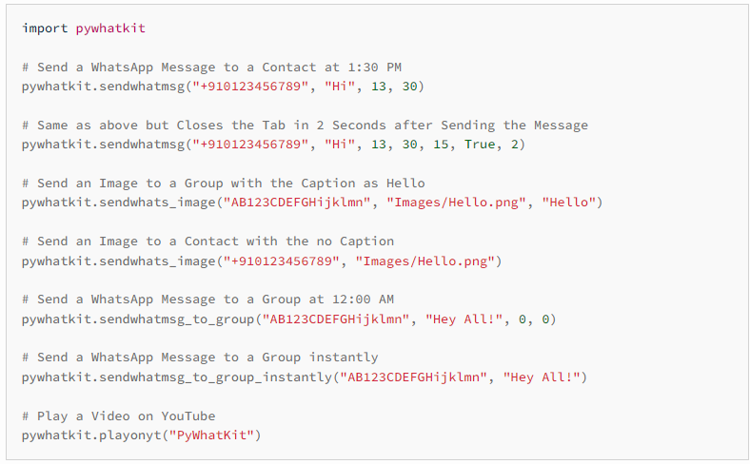

You can try out the rest of the functions yourself.